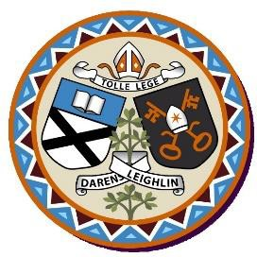
Admission Policy and Application Form

in respect of admissions to the 2026-2027 school year

A copy of the school’s Admission Policy and the Application Form for Admission for Scoil Bhríde is available as follows: –
To download at: https://www.scoilbhrideathgarvan.com/ or
On request: By emailing emerstuddert@scoilbhrideathgarvan.com or writing to Scoil Bhríde, Athgarvan, The Curragh, Co Kildare.

PART 1 - ADMISSIONS TO THE 2026/27 SCHOOL YEAR

Application and Decision Dates for admission to 2026/27
The following are the dates applicable for admission to Junior Infants

The school will commence accepting applications for admission on | 08/10/2025
The school shall cease accepting applications for admission on | 05/11/2025
The date by which applicants will be notified of the decision on their  application is | 27/11/2025
The period within which applicants must confirm acceptance of an offer of  admission is | 11/12/2025

Note: The school will consider and issue decisions on late applications in accordance with the school’s
Admission Policy.
Failure to accept an offer within the prescribed period above may result in the offer being withdrawn

Scoil Bhríde does not have a Special Class

The number of places being made available in junior infants | 52
Part 2 - Admissions to the 2026/2027 School Year

In respect of the 2025/2026 school year, the total number of applications for admission received by the school was 66

Breakdown of places allocated for the 24/25 school year:
Number of places available: | 26
Number of applications received:  • Children from Athgarvan area.  • Children with siblings (and step siblings residing at the same address) attending Scoil Bhríde.  • Children of permanent staff members.  • Children from outside Athgarvan area. | 66  18  5  0  3
Number of Offers made and accepted | 26
Total number of offers made | 33
Number of names placed on waiting list for  the school year concerned. | 33

