

Enabling technology to enhance children’s learning
ICT & Digital Plan
Version 2
November 2021

2021 – 2024 / 25

Table of Contents

Note from Board of Management 2
Three-Year ICT & Digital Plan School Year 2021/22 – 2024/25 3
Attitude Towards E-Learning 5
Proposed Three-Year Plan 7
Timeline Summary – IT Resources 9
Digital Learning Action Plan 10
Ratification 17
Appendix A 18
Appendix B 20
Appendix C 21

Tables

Table 1: Examples of Cloud Based Tools & Applications for Education 6
Table 2: Summary Timeline – New IT Asset Expenditure 9
Table 3: Statements & Standards Priorities 10
Table 4: DLAP - Learner Outcomes #1 11
Table 5: DLAP - Learner Experiences #1 11
Table 6: DLAP - Teachers’ Individual Practice #1 12
Table 7: DLAP - Teachers’ Individual Practice #2 13
Table 8: DLAP – Learner Outcomes #2 14
Table 9: DLAP – Teachers’ Individual Practice #3 15
Table 10: DLAP – Learner Experiences #2 16
Table 11: Building ICT into Learning 2021 - 2024 19
Table 12: List of iPad Apps for Classroom 20

Figures

Figure 1: Example of the ideal School Network 4
Figure 2: Bloom’s Revised Technology Taxonomy for Education 6

Note from Board of Management

Dear Parents,
The past year has changed the role that technology plays in education forever. After two extended periods of remote teaching and learning, children and teachers have learnt so many new skills and adapted rapidly to the changed environment of remote learning. It is now essential that we continue to utilise the IT skills we have learnt in the classroom and at home. Nobody could have predicted the speed that technology in education and further afield would have advanced in such a short timeframe. In a few short years, the school of the future will be very different from the current ones.
The classroom today is shifting towards a virtual reality coupled with interactive technology. Even the smallest child engages wholeheartedly with interactive learning tasks in class. With these technologies playing an active role in everyday commercial and personal life, schools are endeavouring to integrate more into the Information Communications and Telecommunications (ICT) world. Many classroom activities will be carried out electronically, combining traditional learning methods with interactive learning.
The school of the future will likely change the relationship between teacher and student where every student and teacher will have access to a “connected” classroom of interactive boards, laptops and tablets making the teacher a facilitator of knowledge. Children will learn to develop the skills to access required information. There are numerous opportunities for children and classes to engage in fun interactive learning in class every day.
In line with Department of Education Digital Strategy for Schools 2015-2020 whitepaper, the Board of Management wishes to develop a three-year ICT & Digital plan for the children and teachers of Scoil Bhríde National School. This plan will become the bedrock to future education methods in Scoil Bhríde Primary School. The Department of Education has recently conducted a digital Strategy for Schools Framework. Information gathered through this consultation process will inform the next Digital Strategy for schools due in 2021.
Noreen Duggan
(Chairperson, Board of Management)

Three-Year ICT & Digital Plan School Year 2021/22 – 2024/25

Introduction
The development of this plan was set out by the school to bring it broadly in-line with the Department of Education publications ‘circular 0001/2017’ and ‘Digital Strategy for Schools 2015-2020’. There are four key themes laid out in the circular and digital strategy plan four of which can be reviewed in Appendix C.
- Theme 1: Teaching, Learning and Assessment using ICT
- Theme 2: Teacher Professional Learning ICT
- Theme 3: Leadership, Research and Policy
- Theme 4: ICT infrastructure
Within the proposed three-year ICT and Digital plan for the school, the Board of Management intends to focus on aspects of each theme. Theme four is a high priority as the school lacks the ICT infrastructure to deliver a robust platform in the delivery of any future digital learnings. Much of the current ICT resources of the school are aging and some require short to medium term replacement.
Nine interactive panels have been installed across classrooms and special education rooms since May 2021. These replaced older short-throw projectors and interactive whiteboards that had either reached their end of service and/or end of life.
Interactive panels were installed in all three special education classrooms for the first time in August 2021.

Current IT & ICT Resources
These resources do not include the current broadband connectivity and computer networking and data points which are a vital requirement to use any PCs and/or laptops connected to either a wired or wireless network to enable the use of online learning platforms or cloud based educational services.

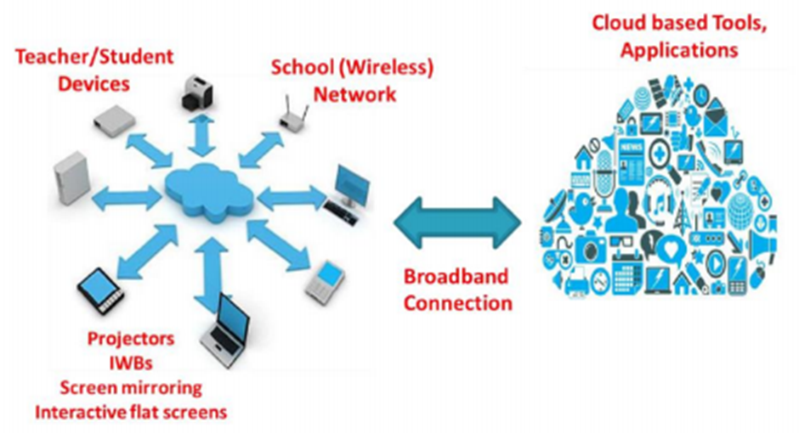
Figure 1: Example of the ideal School Network

Attitude Towards E-Learning

In line with the guidance provided by the PDST (Technology in Education) and NCSE, the approach in Scoil Bhríde is to emphasise the integration of key ICT resources across the curriculum in order to improve the quality of teaching and learning. It is a tool that can add value to the teaching and learning process when it is used appropriately. The purpose is the same as all teaching and learning; to awaken and to support the development of intellectual curiosity.
There are some suggestions that these newer technologies distract children from real learning opportunities much of which could better be accomplished by traditional teaching methods. While children may have a passionate engagement with technology, some research suggests that it can lead them to (click and see) and guesswork answers or detract from time spent socially.
At the same time, we are educating children who live in a technological age (digital natives) and so our teaching and learning must reflect that reality. Pedagogically, e-learning can be highly motivating for the learner and particularly for those children who find the more traditional methodologies of the school setting constraining. In that light, we must strive to maximise the potential for children’s learning using ICT, where appropriate.
Embedding digital technologies in learning, teaching and assessment practices cuts across all subjects, school departments and programmes and planning needs to be cognisant of the needs, abilities and confidence levels of all children and staff in a school.

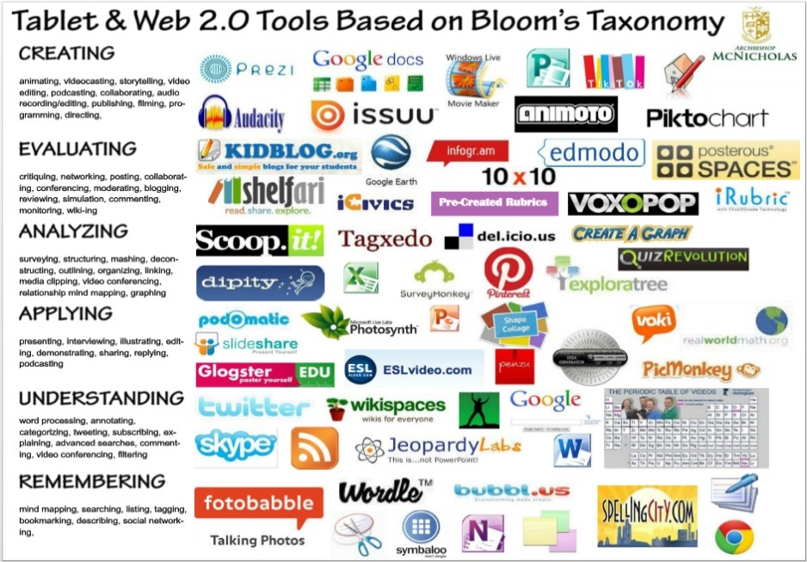

Figure 2: Bloom’s Revised Technology Taxonomy for Education

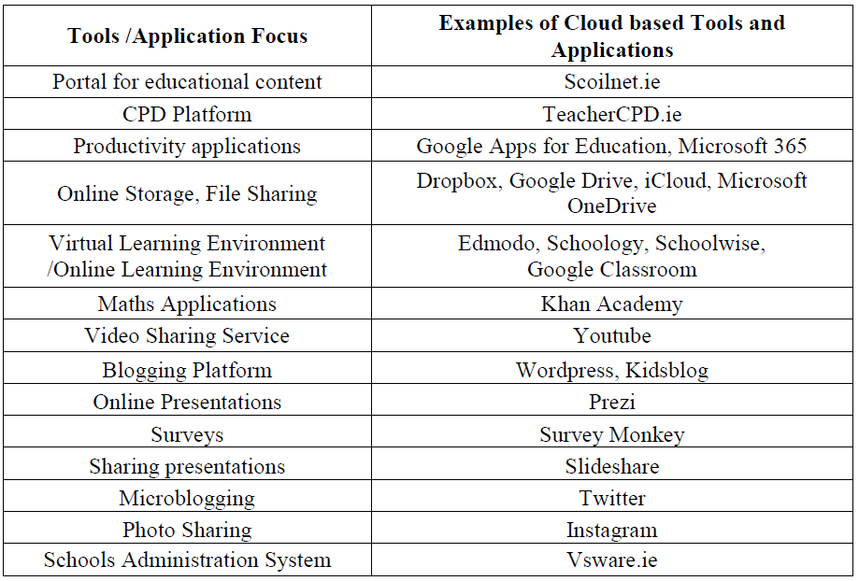

Table 1: Examples of Cloud Based Tools & Applications for Education

Proposed Three-Year Plan

Aim
- To develop a clear rationale for the embedding of digital technologies in teaching and learning in Scoil Bhríde and to inform subsequent decisions as to the type of infrastructure the school should develop.
- To facilitate a whole school approach to understanding what it means to embed digital technologies using constructivist principles for teaching and learning.
- To provide more flexibility for teachers to experiment with different cloud-based applications and learning methods.
- To promote collaboration between teachers and support collaborative planning across class levels and in areas, like literacy, numeracy and STEAM, requiring a cross-curricular focus.
- To facilitate the introduction of iPads in classrooms.
- To teach all pupils how to use the internet safely by teaching sensible use of it.

Vision
Pupils will:
- Commence the usage of iPads in the classroom to aid teaching, learning and assessment
- Engage with and improve computer skills across all class levels
- Be motivated and inspired through developing skills in technologies
- Safely and effectively use cloud-based technologies as a learning aid

Staff will:
- Be motivated and inspired to enhance their teaching using tools on interactive panels in each classroom.
- Engage with online resources through interactive panels and iPads.
- Engage in regular CPD in ICT and engage in the sharing of good practice with other staff members
- Communicate with pupils and parents using a variety of technology
- Use ICT as a tool for assessment across the curriculum

Parents will:
- Continuously update their own skills and knowledge through exploring the potential of new technologies
- Work alongside all staff to develop skills and confidence in the use of new technologies
- Speak to their children about internet safety

Timeline Summary – ICT Resources

Below is a rough timeline of change broken into a plan of IT resources for replacement and/or capital outlay projects. Please note, this is a rough guideline as funding from Department of Education through ICT grants and Parent Association fundraising along with keeping up “highest priority” ICT resource replacement has a huge bearing in the overall proposed three-year plan. In summary:

Timeline – New ICT Resources Expenditure
Timeline | Summary | Deliverable | Estimated  Budget
Year 1  2021 - 2022 | Purchase remaining 6  75” Promethean Nickel Interactive Panels | Purchase 36 iPads, with Covers, 2 Charging Trolleys, Management System | €31, 558
Year 2  2022 – 2023 | Purchase 18 Laptops  Purchase short throw projector and Interactive Board for GP Hall | Purchase 18 iPads with Covers, one Charging Trolley, Management System | €23,699
Year 3  2023 - 2024 | Purchase 10 Chrome Books with cases | Purchase 18 iPads with Charging Trolley, Covers and Management System | €10,279
Total | €65,536
Table 2: Summary Timeline – New IT Asset Expenditure

Digital Learning Action Plan

The staff of Scoil Bhríde has prioritised the following Statements and Standards as targets for the year 2021-2022. We will update these each year after the plan is reviewed.

Standard | Statement
Pupils enjoy their learning, are motivated to learn and expect to achieve as learners. | Pupils use appropriate digital technologies to foster active engagement in attaining appropriate learning outcomes.
Pupils grow as learners through respectful interactions and experiences that are challenging and supportive. | Pupils use digital technologies for sourcing, exchanging of information to develop understanding and support basic knowledge creation.
The teacher has the requisite subject knowledge, pedagogical knowledge and classroom management skills. | Teachers use a range of digital technologies to design learning and assessment activities for their pupils.
The teacher selects and uses planning, preparation and assessment practices that progress pupils’ learning. | Teachers use a range of digital technologies to support assessment of learning and assessment for learning.
Pupils demonstrate the knowledge, skills and understanding required by the primary curriculum. | Pupils can use a range of digital technologies to demonstrate the knowledge, skills and understanding required by the Primary School Curriculum.
The teacher selects and uses teaching approaches appropriate to the learning objective and to pupils’ learning needs. | Teachers are aware of, and purposefully use, a range of digital technologies appropriate to the learning objectives and learning needs of their pupils when designing learning activities.
Pupils grow as learners through respectful interactions and experiences that are challenging and supportive. | Pupils use digital technologies for sourcing, exchanging of information to develop understanding and support basic knowledge creation.
Table 3: Statements & Standards Priorities

Domain – Learner Outcomes #1
STANDARD(S): Pupils enjoy their learning, are motivated to learn and expect to achieve as learners.
STATEMENT(S): Pupils use appropriate digital technologies to foster active engagement in attaining appropriate learning outcomes.
TARGETS: To use iPads to promote and encourage writing skill in line with school policy (Junior – 2nd).
ACTIONS  (What needs to be done?) | TIMEFRAME  (When is it to be done by?) | PERSON(S) RESPONSIBLE  (Who is to do it?) | CRITERIA FOR SUCCESS  (What are the desired outcomes?) | RESOURCES  (What resources are needed?)
- Staff training  - Appropriate Apps selected  - Class iPads | - Sept - Dec | - Class Teacher  - Support Teacher  - ICT Coordinator | Children use iPads to improve writing letter formation | - Set of iPads  - iPad pens  - Teacher iPad  - Writing app
EVALUATION PROCEDURES: (How are we progressing? Do we need to adjust? Have we achieved our targets?)
- Review at staff meeting (continuous).
Table 4: DLAP - Learner Outcomes #1

Domain – Learner Experiences #1
STANDARD(S): Pupils grow as learners through respectful interactions and experiences that are challenging and supportive.
STATEMENT(S): Pupils use digital technologies for sourcing, exchanging of information to develop understanding and support basic knowledge creation.
TARGETS: iPads to be used independently for research through Worldbookonline and DKFindOut for S.E.S.E lessons (3rd – 6th).
ACTIONS  (What needs to be done?) | TIMEFRAME  (When is it to be done by?) | PERSON(S) RESPONSIBLE  (Who is to do it?) | CRITERIA FOR SUCCESS  (What are the desired outcomes?) | RESOURCES  (What resources are needed?)
- Staff training  - Appropriate Apps selected (see appendix B)  - iPads (timetabled) | - Sept - Dec | - Class Teacher  - SET Teacher  - ICT Coordinator | Children will be enabled to use apps at the independent station to support research in S.E.S.E lessons | - iPads  - Apps
EVALUATION PROCEDURES: (How are we progressing? Do we need to adjust? Have we achieved our targets?)
- Review at staff meeting at the end of November.
- Include the voice of the Student Council and ICT Committee (children).
Table 5: DLAP - Learner Experiences #1

Domain – Teachers’ Individual Practice #1
STANDARD(S): The teacher has the requisite subject knowledge, pedagogical knowledge and classroom management skills.
STATEMENT(S): Teachers use a range of digital technologies to design learning and assessment activities for their pupils.
TARGETS: Using Kahoot as an assessment tool.
ACTIONS  (What needs to be done?) | TIMEFRAME  (When is it to be done by?) | PERSON(S) RESPONSIBLE  (Who is to do it?) | CRITERIA FOR SUCCESS  (What are the desired outcomes?) | RESOURCES  (What resources are needed?)
- Staff training  - Kahoot put onto iPads  - iPads (timetabled) | - Sept - Dec | - Class Teacher  - ICT Coordinator | - Children will use Kahoot to answer questions based on a topic of the class teacher’s choice  - Teachers will share codes for quizzes | - iPads  - Kahoot App
EVALUATION PROCEDURES: (How are we progressing? Do we need to adjust? Have we achieved our targets?)
- Review at staff meeting at the end of November.
- Include the voice of the Student Council and ICT Committee (children).
Table 6: DLAP - Teachers’ Individual Practice #1

Domain – Teachers’ Individual Practice #2
STANDARD(S): The teacher selects and uses planning, preparation and assessment practices that progress pupils’ learning.
STATEMENT(S): Teachers use a range of digital technologies to support assessment of learning and assessment for learning.
TARGETS: iPads used for Literacy and numeracy containing digital element. Using QR code for reading and research and games (station teaching).
ACTIONS  (What needs to be done?) | TIMEFRAME  (When is it to be done by?) | PERSON(S) RESPONSIBLE  (Who is to do it?) | CRITERIA FOR SUCCESS  (What are the desired outcomes?) | RESOURCES  (What resources are needed?)
- Staff Training  - Suitable Apps put on iPads  - QR codes printed  - Class iPads QR finder app installed | - Sept - Dec | - All Teachers  - ICT Coordinator | - Use of QR codes for literacy and numeracy stations (JI- 2nd)  - Mentimeter will be used to assess understanding (3rd-6th) | - iPads  - Internet  - Earphones
EVALUATION PROCEDURES: (How are we progressing? Do we need to adjust? Have we achieved our targets?)
- Review at staff meeting at the end of November.
- Include the voice of the Student Council and ICT Committee (children).
Table 7: DLAP - Teachers’ Individual Practice #2

Domain – Learner Outcomes #2
STANDARD(S): Pupils demonstrate the knowledge, skills and understanding required by the primary curriculum.
STATEMENT(S): Pupils can use a range of digital technologies to demonstrate the knowledge, skills and understanding required by the Primary School Curriculum.
TARGETS: Children will develop their computer literacy skills in conjunction with class level. (Appendix A).
ACTIONS  (What needs to be done?) | TIMEFRAME  (When is it to be done by?) | PERSON(S) RESPONSIBLE  (Who is to do it?) | CRITERIA FOR SUCCESS  (What are the desired outcomes?) | RESOURCES  (What resources are needed?)
- iPad Timetable  - Staff Training | - Sept’21 – Dec’21 | - All Classroom Teachers  - ICT Coordinator | Teachers to use sample apps and programs and choose most appropriate literacy apps/websites for their class level | - Access iPads  - Relevant programmes for teaching specific skills (Appendix B)  - Specific literacy apps to class level
EVALUATION PROCEDURES: (How are we progressing? Do we need to adjust? Have we achieved our targets?)
- Review at staff meeting at the end of November.
- Include the voice of the Student Council and ICT Committee (children).
Table 8: DLAP – Learner Outcomes #2

Domain – Teachers’ Individual Practice #3
STANDARD(S): The teacher selects and uses teaching approaches appropriate to the learning objective and to pupils’ learning needs.
STATEMENT(S): Teachers are aware of, and purposefully use, a range of digital technologies appropriate to the learning objectives and learning needs of their pupils when designing learning activities.
TARGETS: Teachers will use Promethean Interactive panels to access the online resources provided by publishers to develop lessons.
ACTIONS  (What needs to be done?) | TIMEFRAME  (When is it to be done by?) | PERSON(S) RESPONSIBLE  (Who is to do it?) | CRITERIA FOR SUCCESS  (What are the desired outcomes?) | RESOURCES  (What resources are needed?)
- Staff Training on using Promethean interactive panels with online resources | - Sept - Dec | - All Classroom Teachers  - ICT Coordinator | Sharing of information among staff members | - Busy at Maths  - Bua Na Cainte  - Abair Liom  - Jolly Phonics  - Go with the flow  - Folens Explorer  - Starlight  - Numicon interactive  - IZAC9  - Grow in Love
EVALUATION PROCEDURES: (How are we progressing? Do we need to adjust? Have we achieved our targets?)
- Review at staff meeting at the end of November.
- Include the voice of the Student Council and ICT Committee (children).
Table 9: DLAP – Teachers’ Individual Practice #3

Domain – Learner Experiences #2
STANDARD(S): Pupils grow as learners through respectful interactions and experiences that are challenging and supportive.
STATEMENT(S): Pupils use digital technologies for sourcing, exchanging of information to develop understanding and support basic knowledge creation.
TARGETS: iPads to be used at the independent station in Literacy lift off.
ACTIONS  (What needs to be done?) | TIMEFRAME  (When is it to be done by?) | PERSON(S) RESPONSIBLE  (Who is to do it?) | CRITERIA FOR SUCCESS  (What are the desired outcomes?) | RESOURCES  (What resources are needed?)
- Staff training  - Appropriate Apps selected (Appendix B) | - Sept’21 – Apr’22 | - Classroom Teacher  - SET Teacher  - ICT Coordinator | Children will be enabled to use apps at the independent station to support Lift off to Literacy lessons | - iPads  - Apps
EVALUATION PROCEDURES: (How are we progressing? Do we need to adjust? Have we achieved our targets?)
- Review at staff meeting (continuous).
Table 10: DLAP – Learner Experiences #2

Ratification

Proposed Three-Year ICT & Digital Plan 2021/22 – 2024/25

Policy adopted by the Board of Management on 9th November 2021.

Signed: _________________________ Signed: __________________________
Chairperson of Board of Management Principal

Date: __________________________ Date: ____________________________

Date of next review: ______________

Appendix A
Building ICT into Learning 2021 - 2024
Rang | iPads | Computer Skills | IWB & Resources
JI | - Cursive writing formation  - QR codes for literacy and numeracy stations  - Aistear – optional | - Exploration  - Use QR codes  - Log on to seesaw, take a picture | - Bua Na Cainte  - Jolly Phonics  - Grow in Love  - Go with the flow  - Folens explorer  - Starlight oral language  - Numicon interactive
SI | - Cursive writing formation  - QR codes for literacy and numeracy stations  - Use Kahoot as an assessment tool  - Aistear – optional | - Exploration  - Use QR codes  - Log on to seesaw, take a picture | - Bua Na Cainte  - Jolly Phonics  - Go with the flow  - Folens explorer  - Starlight  - Grow in Love  - Numicon interactive
1st | - Cursive writing  - QR codes for literacy and numeracy stations  - Use Kahoot as an assessment tool | - Use QR codes  - Exploration  - Selecting appropriate buttons to answer  - Log onto seesaw, upload a picture, use a variety of tools | - Busy at Maths  - Bua Na Cainte  - Jolly Phonics  - Starlight  - Folens explorers  - Grow in Love  - Numicon interactive
2nd | - Cursive writing  - QR codes for literacy and numeracy stations  - Use Kahoot as an assessment tool  - Green Screen for presentations | - Use QR codes  - Saving a picture  - Selecting appropriate buttons to answer  - Recording a video | - Busy at Maths  - Bua Na Cainte  - Jolly Phonics  - Grow in Love  - Go with the flow  - Starlight  - Explorer  - Numicon interactive
3rd | - S.E.S.E research through Worldbookonline and DK Findout  - Use Kahoot as an assessment tool  - Using Seesaw as a SALF folder  - Typing programme | - Use QR codes  - Select app independently  - Use a search bar to find appropriate information  - Type answers to give opinion  - Display work in digital form (open a word document, type, change font size and colour, save document) | - Busy at Maths  - Abair Liom  - Grow in Love  - Starlight  - Explorer
4th | - S.E.S.E research through Worldbookonline and DK Findout  - Use Kahoot as an assessment tool  - Use Seesaw as a SALF folder  - Typing programme | - Save and annotate a picture  - Use a search bar to find appropriate information  - Type answers to give opinion  - Display work in digital form (build on skills from 3rd class, add a picture and a table to a document) | - Busy at Maths  - Abair Liom  - Grow in Love  - Starlight  - Explorer
5th | - S.E.S.E research through Worldbookonline and DK Findout  - Use Kahoot as an assessment tool  - Mentimeter for presentations  - Typing programme | - Use a search bar to find appropriate information  - Type answers to give opinion  - Display work in digital form  - Create digital presentation (PowerPoint presentation, open, type, add picture from internet, add slides, save) | - Busy at Maths  - Abair Liom  - IZAK 9  - Grow in Love  - Explorers  - Starlight
6th | - S.E.S.E research through  - Worldbookonline and DK Findout  - Use Kahoot as an assessment tool  - Mentimeter/ iMovie | - Use a search bar to find appropriate information  - Type answers to give opinion  - Create their own Kahoot Quiz/ digital presentation/ iMovie project  - (PowerPoint presentation, open, type, add picture from internet, save, use custom animation) | - Busy at Maths  - Abair Liom  - IZAk 9  - Explorers  - Starlight  - Grow in love
Table 11: Building ICT into Learning 2021 - 2024

Appendix B
A list of apps that can be used in the classroom
List of iPad Apps
QR Code Scanner – Orienteering (1st- 6th) | SeeSaw | Duo Lingo
Piano Tiles – Music (1st - 6th) | Padlet (oral language/brainstorming/gathering information) | Showbie
Minecraft Edu - Maths/Science (3rd - 6th) | *Explain everything | Skitch
Quizlet – Assessment | *Chatterpix kids | Clips
Kahoot - Assessment (1st- 6th) | *Draw and tell | Morfo
Maths fight - Numeracy (1st- 6th) | *Clics | Garage Band
Word cookies – Literacy (SI to 6th) | *Scratch Junior | Pic Collage
Pixelart - Visual Art (JI - 6th) | Rory's story cubes - English | Puppet Pals
Blockworld - Maths/Numeracy (3rd - 6th) | *Book creator - English | Tellagami
Lego WeDo - SESE (3rd - 6th) | *A+ Spelling – English | iTunes U
Moviemaker - Music/Drama (1st- 6th) | Jolly Phonics – English | Swift Playgrounds
Lightbot - Coding 2nd- 6th | Brainpop jr. – Science | Adobe Spark Video
Kodable - Coding (4th - 6th) | Pieces basic: place value 1st/2nd class | Tynker
Code - a -pillar - Coding (JI – 1st) | Socrative | Sphero Edu
Scratch – Coding (4th - 6th) | Explain Everything | Maps
Lego WeDo – Coding | Keynote | Classroom
Procreate – Art (2nd – 6th) | Pages | Aurasma
King of Maths – Maths | Book Creator | MSQRD
iMovie | Brainscape
Table 12: List of iPad Apps for Classroom

Appendix C

(Theme 1): Teaching, Learning and Assessment using ICT
ICT integration in the Curriculum (Teaching, Learning and Assessment using ICT)
- Formulate clear statements regarding digital skills and learning outcomes in our school plan
- Formulate an e-learning plan and digital strategy
- Avail of CPD for teachers giving examples of practice on the use of ICT for teaching, learning and assessment
- Avail of and make available high-quality digital content to support learning and teaching
- DIGITAL LEARNING FRAMEWORK FOR PRIMARY SCHOOLS – Teaching and Learning
Domain 1: Learner Outcomes
Domain 2: Learner Experiences
Domain 3: Teacher’s Individual Experience
Domain 4: Teachers’ Collective/Collaborative Practice

(Theme 2): Teacher Professional Learning ICT
Continuing Professional Development (Teacher Professional Learning)
- Recognise the role and potential of ICT to enhance teaching and learning in your school plan
- Avail of Department funded support services on the use of ICT
- Guidance and examples of good practice on the effective, critical and ethical use of ICT for teaching, learning and assessment are provided to and shared by teachers
- DIGITAL LEARNING FRAMEWORK FOR PRIMARY SCHOOLS – Teaching and Learning
Domain 3: Teacher’s Individual Experience
Domain 4: Teachers’ Collective/Collaborative Practice

(Theme 3): Leadership, Research and Policy
Leadership and Vision
- Recognise the role and potential of ICT to enhance teaching, learning and assessment
- Structures are established to provide oversight of and guidance on the implementation of the strategy
- Avail of guidance, planning resources and related supports for the effective, safe and ethical use of ICT
- Appropriate linkages are developed with other school policies
- DIGITAL LEARNING FRAMEWORK FOR PRIMARY SCHOOLS – Leadership and Management
Domain 1: Leading Learning and Teaching
Domain 2: Managing the Organisation
Domain 3: Leading School Development
Domain 4: Developing Leadership Capacity

(Theme 4): ICT Infrastructure
Resources and Infrastructure
- Avail of improved connectivity with ICT funding for the Department
- Avail of grants scheme for the purchase of equipment
- Avail of guidance and advice for the purchase of equipment and services
- Avail of guidance on the innovative use of ICT for teaching and learning

-------------------- END OF DOCUMENT --------------------

