Notification regarding the Board of Management’s annual review of the Anti-bullying policy

To: The Chairperson of the Parents’ Association

The Board of Management of Scoil Bhríde, Athgarvan wishes to inform you that: The Board of Management’s annual review of the school’s anti-bullying policy and its implementation was completed at the Board meeting of October 7th 2024.

This review was conducted in accordance with the checklist set out in Appendix 4 of the Department’s Anti-Bullying Procedures for Primary and Post-Primary Schools.

Signed

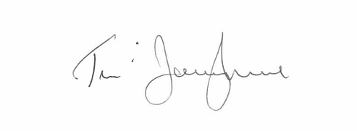
Tom O’Donoghue
Chairperson, Board of Management

Date: 7th October, 2024

Signed

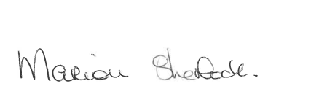

Marion Sherlock
Principal

Date: 7th October 2024

